Summer Group Class Schedule
No cell phones allowed during classes. Please step into the hallway.
Time | Mon. | Tues. | Wed. | Thurs. | Fri.
6-6:45am  Starts June 9th |  | Rise and Shine Yoga w/ Natalie |  | Rise and Shine Yoga w/ Natalie
12:15-12:50p | Back to Basics w/ Dee Dee | Senior Strength Circuit w/ Dee Dee | Back to Basics w/ Dee Dee | Senior Strength Circuit w/ Dee Dee | Pickleball 12-1:30pm
4:15pm | Yoga w/ Sarah |  | Yoga w/ Sarah
Beginners are welcome in all classes and always encouraged to modify movements as necessary.
Class Descriptions
Back to Basics | We brought back some old school fitness that we all knew and loved. We do a variety of low impact aerobics, Step, functional movements, and toning exercises.
Senior Strength Circuit | This is a 35-40 min. circuit for all fitness levels. We perform movements for strength, mobility and balance. All ages and abilities are welcome. Afterward, some folks stay for a 15 min. session of walking fitness.
Yoga | This is a 60 min. class for the beginner/ intermediate yoga student. Session ends w/ 10-15 min. of relaxation.
Rise and Shine Yoga | This is a 45 min. yoga class to wake you up and get you read for the day.

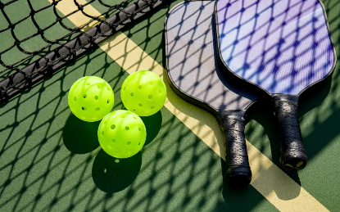
Want to learn how to play Pickleball?
Join us on Friday, June 26th ,12-2pm, for a beginner’s clinic. We will meet inside the Fitness Complex gym. This event is open to the public and we will provide all necessary equipment.
To reserve your spot, call Dee Dee at
806-716-2236 or email
dninemire@southplainscollege.edu

