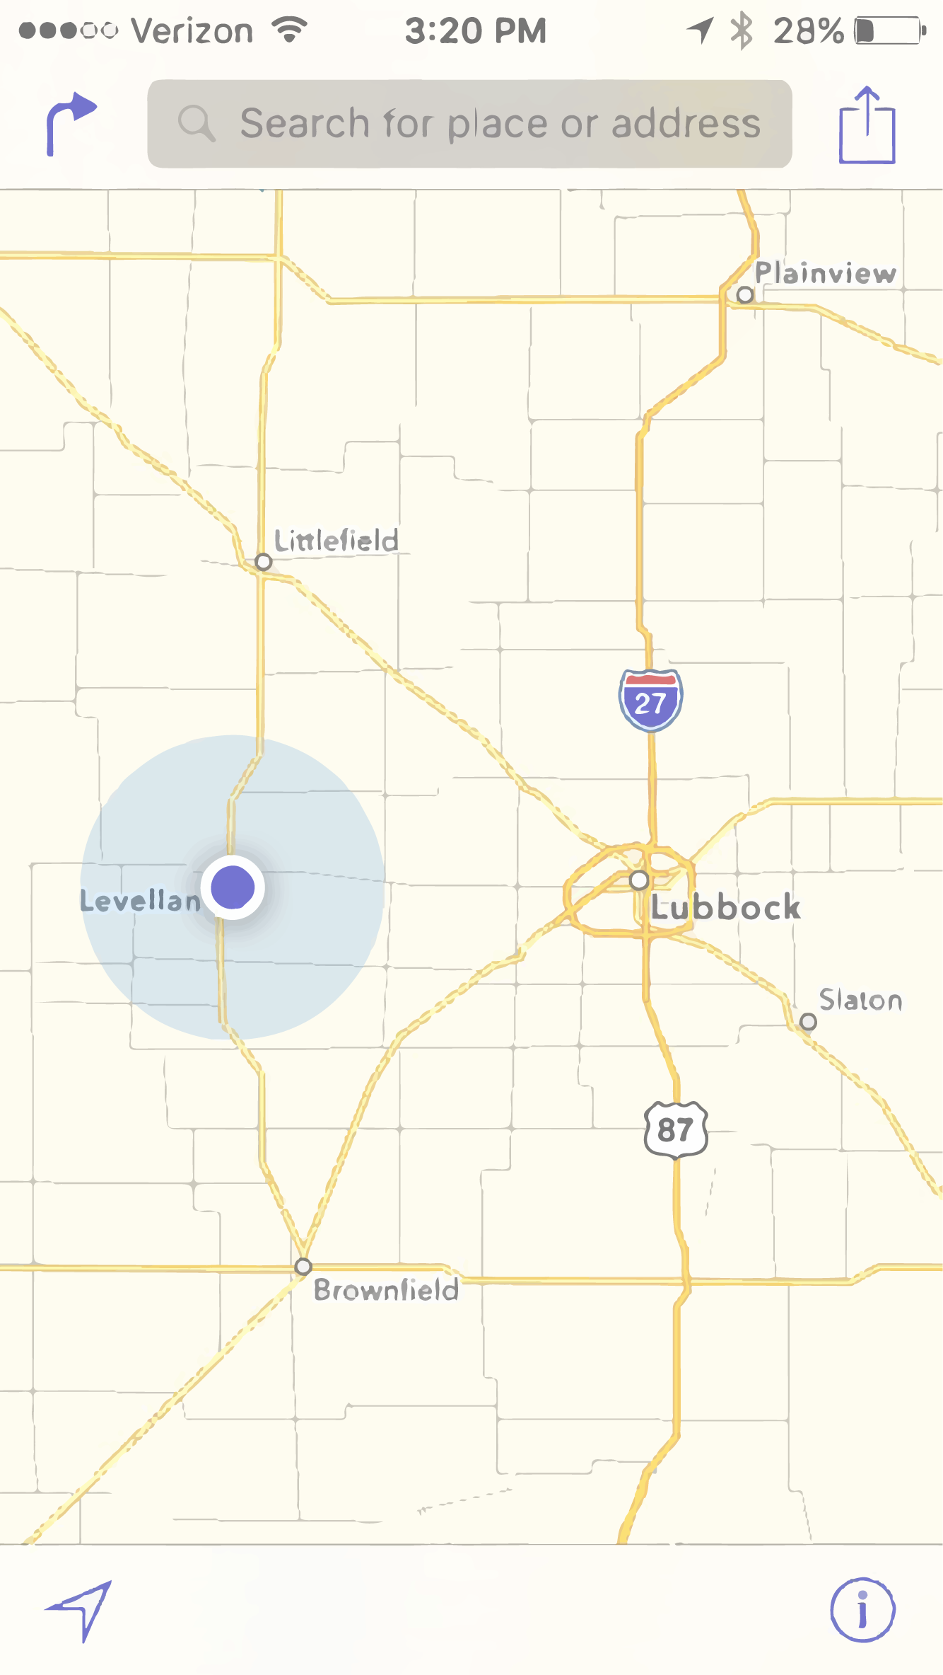

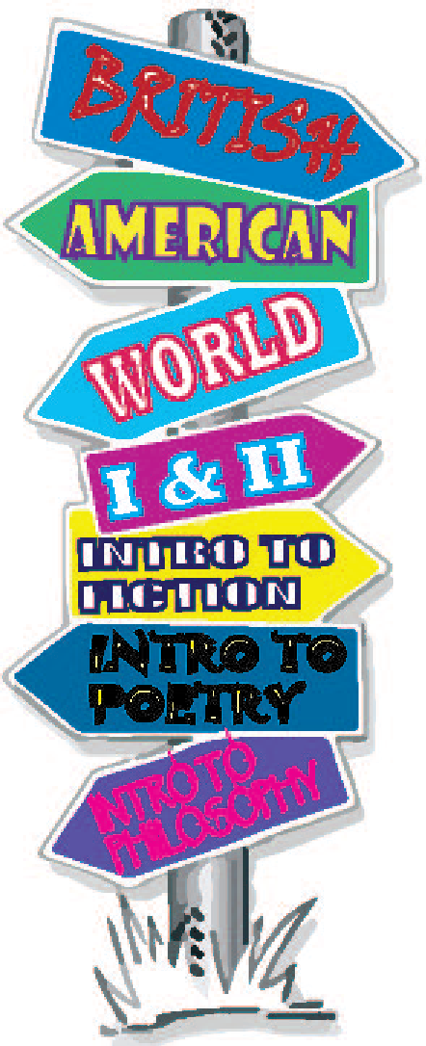

Top 5 Reasons to Take a Sophomore English Course

**5**  **To graduate with an Associate’s or Bachelor’s degree, you must take a Humanities requirement (also called Language, Philosophy, and Culture), which can be a sophomore level English course or a Philosophy course.**

**4 SPC offers an enormous variety of Sophomore English classes that are challenging, intriguing and fascinating.**

**3 Most universities require one or two sophomore literature courses for a four-year degree.**

**2 You can mix and match sophomore literature courses and take them in any order!**

**1 SPC offers sophomore literature courses that are required by most Universities at a more economical cost.**



ENGL 2321: British Literature

Does everything British interest you . . . the neat accent, kings and queens, the traditions, the rich history? Do you enjoy epic tales of battles and romances, monsters and heroes, knights and maidens? Do you like *Harry Potter* and *Lord of* *the Rings*? If you’re interested in seeing how literature and pop culture, fiction and film collide, sign up for British Literature!* *Prerequisite: ENGL 1301 and ENGL 1302.*

***Mrs. Ashleigh Brewer,*** *Assistant Professor of English,* [*abrewer@southplainscollege.edu*](mailto:abrewer@southplainscollege.edu) *(Levelland)*

ENGL 2326: American Literature

Does everything American interest you? Do you admire the independent, patriotic American spirit? Experience the history, art, and rise of a nation by studying America’s literary legacy!

*Prerequisite: ENGL 1301 and ENGL 1302.*

**Option 1:** Read authors like James Thurber (“The Secret Life of Walter Mitty”), Washington Irving ("The Legend of Sleepy Hollow"), Edgar Allan Poe, Ernest Hemingway, William Faulkner, Maya Angelou, Flannery O’Connor, Thomas Jefferson, and more.*

***Ms. Kay McClellan****, Associate Professor of English,* [*kmcclellan@southplainscollege.edu*](mailto:kmcclellan@southplainscollege.edu)

**Option 2:** Learn about the major literary movements in American literature, such as Gothicism, Realism, Naturalism, and Modernism! Read authors like Edgar Allan Poe, Nathanial Hawthorne, Charlotte Perkins Gilman, Joyce Carol Oates, Kate Chopin, Flannery O’Connor, John Steinbeck, and more.*

***Ms. Glenda Bryant****, Associate Professor of English,* [*gbryant@southplainscollege.edu*](mailto:gbryant@southplainscollege.edu) *(Internet)*



ENGL 2328: American Literature II Since 1865

(*Prerequisite: ENGL 1301 and ENGL 1302)*

Southern Gothic Literature: Travel to the American south and see what happens when perceptions of genteel society and history collide with the bleak realities of racism, sexism, poverty, and violence. Deformed and grotesque characters, metal instability, emotional ineptitude, moral depravity, and the supernatural highlight inherent tensions between social norms and oppression.

***Dr. Roy Bearden-White****, Assistant Professor of English,* [*rbearden-white@southplainscollege.edu*](mailto:rbearden-white@southplainscollege.edu) *(Levelland)*

ENGL 2332: World Literature I

(*Prerequisite: ENGL 1301 and ENGL 1302)*

Do you know these famous works of literature: Old Testament (Job, Psalms), Homer’s *Odyssey*, Aesop’s Fables, Sophocles’ *Oedipus*, Plato, Dante’s *Inferno*, *Beowulf*, Chaucer’s *Canterbury Tales*, Gilgamesh, Agamemnon, Lysistrata, Medea, Shakespeare’s *Macbeth* and *Hamlet*?* No? Then you need to change that! Being able to recognize references to literary masterpieces is an important asset to have. You want to sound as educated and well-rounded in social and career circles as everyone else, right? Get smarter with some of the great works of literature, from the Ancient World through the Renaissance, in World Literature I!

*Prerequisite: ENGL 1301 and ENGL 1302.*

***Mr. Joseph Fly****, Professor of English,* [*jfly@southplainscollege.edu*](mailto:jfly@southplainscollege.edu) *(Reese)*

***Mrs. Patti Thompson****, Instructor in English,*

[*pthompson@southplainscollege.edu*](mailto:pthompson@southplainscollege.edu) *(Reese)*

ENGL 2333: World Literature II

Do you enjoy modern literature on a global scale? If so, experience history, art, and the evolution of modern literature through post-Renaissance masterpieces in World Lit II. View social revolution in **Neoclassicism;** connect with metaphysical and supernatural worlds, romance, medieval settings, secret passages, monsters, and twisted people in **Gothicism;** embrace feelings, the supernatural, and nature through **Romanticism**; view a slice of life in **Realism**; examine dysfunction, perseverance, and

triumph of the human spirit in **Modernism**; and venture into today's fragmented and psychologically dysfunctional world in **Postmodernism**. Readings may include Voltaire's *Candide*; Stevenson's *The Strange Case of Dr. Jekyll and Mr. Hyde;* Stoker's *Dracula;* the poetry of Eliot, Keats, and Wordsworth; Kate Chopin; Guy de Maupassant, Ernest Hemingway, Wilbur Daniel Steele; Ursula LeGuin; Alain Robbe-Grillet, and Frankenstein.* Prerequisite: ENGL 1301 and ENGL 1302.

***Ms. Kay McClellan****, Associate Professor of English,* [*kmcclellan@southplainscollege.edu*](mailto:kmcclellan@southplainscollege.edu) *(Levelland*

***Mrs. Patti Thompson****, Instructor in English,* [*pthompson@southplainscollege.edu*](mailto:pthompson@southplainscollege.edu) *(Reese)*

ENGL 2341: Introduction to Fiction

(*Prerequisite: ENGL 1301 and ENGL 1302)*

You have several options for studying fiction next semester:

**Option 1:** Can’t choose between **American and British Literature**? Do both and more in this section that studies a variety of fascinating themes in short stories, novels, and film! This option focuses on a theme of **Virtue & Vice: the good and evil of human nature in story, novel, and film**.  Reading selections include Mark Twain, Edgar Allan Poe, Charles Dickens, Stephen Crane, Leo Tolstoy, Rudyard Kipling, Jack London, Kate Chopin, F. Scott Fitzgerald, James Baldwin, Sandra Cisneros, plus post-9/11 literature and much more!

***Ms. Mollie Moore****, Instructor of English,* [*mmoore@southplainscollege.edu*](mailto:mmoore@southplainscollege.edu) *(Levelland)*

**Option 2**: **Graphic Fiction:** Follow the history of graphic fiction from the uncertain beginnings of the nineteenth century with newspaper comic strips through the Golden Age of the comic book in the 1940s until the current popularity of graphic novels. Along the way, we will try to determine how this popular form of literature provides insight to, and often critiques, contemporary culture.

***Dr. Roy Bearden-White****, Assistant Professor of English,* [*rbearden-white@southplainscollege.edu*](mailto:rbearden-white@southplainscollege.edu) *(Levelland)*

ENGL 2343: Introduction to Poetry

How do you describe having your heart broken, losing a loved one to war, fear of death, political frustration, or simply the sky? Through meaning, sound, form, and rhythmic language, *Introduction to Poetry* explores the foundation of all Western literature, an ancient art form about our humanity that has been reinvented again and again.

*Prerequisites: ENGL 1301 and ENGL 1302.* ***Dr. Roy Bearden-White****, Assistant Professor of*

*English,* [*rbearden-white@southplainscollege.edu*](mailto:rbearden-white@southplainscollege.edu) *(Internet-Summer I only)*

ENGL 2342: Introduction to Drama

Drama is a unique literary collage. This genre combines storytelling and poetry with live performance. From an early form of ritual to entertainment to social commentary, drama has served to unite communities and challenge social norms, to vitalize and provoke its audiences. In this course, we will explore the historical evolution of page and stage from the outdoor theaters of the ancient Greeks up to the well-worn floor boards of the Broadway stage.

*Prerequisites: ENGL 1301 and ENGL 1302.* ***Dr. Roy Bearden-White****, Assistant Professor of*

*English,* [*rbearden-white@southplainscollege.edu*](mailto:rbearden-white@southplainscollege.edu) *(Internet-Summer II only)*

**Continue your journey at South Plains College by signing up for a Sophomore English or Philosophy class next semester!**

PHIL1301:Introduction to Philosophy

*Prerequisite: ENGL 1301 and ENGL 1302.*

As humans, we sometimes ponder the big, deep

questions: What is the meaning of life? What happens when I die? Is there a God, etc.? This course is your chance to deal with important, relevant issues and put an honest effort into attempting to understand them. Topics include being, mind, free will, knowledge, God, evil, ethics, politics, and life’s meaning. PHIL 1301 will help you develop your critical thinking skills, understand the difference between good and bad arguments, and learn to critically and carefully analyze the arguments of others. ***B. Kyle Keltz****, Adjunct Professor* [*bkeltz@southplainscollege.edu*](mailto:bkeltz@southplainscollege.edu) *(Levelland and Reese)*

TO REGISTER FOR A COURSE:

* Log in to [Campus Connect](https://myspc.southplainscollege.edu/ICS/).
* Click Registration Options.
* Add/Drop Courses.

for a list of all sophomore English courses by semester:

* Select your Term code, All Campuses, and **040 Language, Philosophy, and Culture**.
* Click on Display Courses.

***\*Literature/authors/topics listed are representative and not guaranteed. Email instructors to acquire specific reading lists. Not all courses listed above are guaranteed to be offered each semester***

