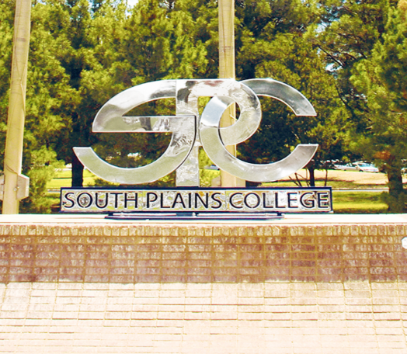
Developing Dental Hygiene Program
Information Packet
Contreras, Lynne | [Date] | [Course title]

Table of Contents

Contents
Table of Contents 1
Welcome to the Developing Dental Hygiene Program Information Packet 2
Accreditation Disclosure 3
Scope of Dental Hygiene Practice 4
Dental Hygiene Employment Opportunities 5
Mission and Goals of the Developing Program 6
Mission 6
Goals 6
Anticipated Admission Requirements and Applicant Preparation 7
Proposed Applicant Evaluation Process 9
Applicant Preparation Checklist 13
Observation Hours Requirement 14
Observation Hours Verification Form 15
Essential Functions and Technical Standards 17
If Selected for Admission 21
Proposed Curriculum 22
Estimated Program Costs 23
Frequently Asked Questions 24

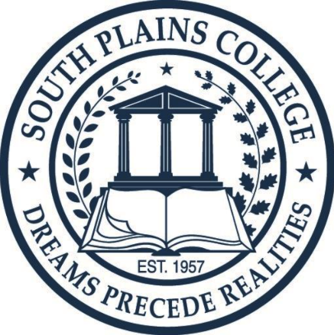

Welcome to the Developing Dental Hygiene Program Information Packet

Thank you for your interest in the developing Dental Hygiene Program at South Plains College.
South Plains College is currently pursuing initial accreditation through the Commission on Dental Accreditation (CODA) and is planning for a Fall 2027 student cohort, pending accreditation approval.
This information packet is intended to help prospective students understand the proposed program requirements and begin preparing for a future application cycle. It outlines anticipated admission requirements, prerequisite coursework, observation expectations, selection criteria, estimated costs, and other important information.
Please note that all information contained in this packet is preliminary and subject to change pending CODA accreditation decisions, institutional approvals, and program development.

Accreditation Disclosure

South Plains College has submitted an application for accreditation for a proposed Dental Hygiene Program and is currently seeking Initial Accreditation from the Commission on Dental Accreditation (CODA).
Submission of an application for accreditation indicates that South Plains College has entered the accreditation process; however, it does not mean that the program is accredited or guaranteed to receive Initial Accreditation.
Initial Accreditation can only be granted by the Commission on Dental Accreditation.
South Plains College cannot enroll students into the proposed Dental Hygiene Program until Initial Accreditation has been granted by CODA.
The College anticipates seeking enrollment for a Fall 2027 cohort of approximately 20 students, contingent upon accreditation approval.
All information contained in this packet is preliminary and subject to change.

Scope of Dental Hygiene Practice

A dental hygienist is a person who practices dental hygiene under a license issued by a state board. They deliver safe, ethical, and evidence-based oral care services to individuals in a variety of settings. Dental hygienists can work in dental offices or clinics, healthcare settings, community health clinics, hospitals, and nursing homes. Dental hygienists can also work in the fields of research, education, administration, dental product sales, and entrepreneurship. They assess clinical findings and risk factors, diagnose factors and classifications (within their scope of practice) affecting an individual’s oral health, plan intervention strategies, implement appropriate interventions, evaluate outcomes, and document relevant data under the supervision of a dentist. The dental hygienist is an integral member of the larger dental team, influencing an individual’s oral and overall health.
*Dental hygienists wear safety glasses, surgical masks, and gloves to protect themselves and their patients from diseases. Dental hygienists examine patients for signs of oral diseases, such as gingivitis, and provide preventive care. They also educate patients about oral health. Dental hygienists typically perform the following services:
- Remove calculus, stains, and plaque from teeth
- Apply sealants and fluorides to help protect teeth
- Take and develop dental x rays
- Assess patients’ oral health and report findings to dentists
- Document patient care and treatment plans
- Educate patients about oral hygiene techniques, such as how to brush and floss correctly
*Bureau of Labor Statistics, U.S. Department of Labor, Occupational Outlook Handbook, Dental Hygienists,
at https://www.bls.gov/ooh/healthcare/dental-hygienists.htm (visited April 18, 2025).

Dental Hygiene Employment Opportunities
*According to U.S. Bureau of Labor Statistics Occupation Outlook Handbook, the occupation of dental hygiene is expected to grow 9%, which is faster than the average for all occupations. Demand for dental services is expected to increase as the large baby-boom population ages and as people keep more of their original teeth than in previous generations.
Studies linking oral health and general health, along with efforts to expand access to oral hygiene services, should continue to drive demand for preventive dental services, including those performed by hygienists.
The median annual wage for dental hygienists was $94,260 ($45.32/hour) in May 2024. The median wage is the wage at which half the workers in an occupation earned more than that amount and half earned less. The lowest 10 percent earned less than $66,470, and the highest 10 percent earned more than $120,060.
Benefits, such as vacation, sick leave, and retirement contributions, vary by employer and may be available only to full-time workers.
Many dental hygienists work part-time. Dentists may hire hygienists to work only a few days a week, so some hygienists work for more than one dentist.
*Bureau of Labor Statistics, U.S. Department of Labor, Occupational Outlook Handbook, Dental Hygienists,
at https://www.bls.gov/ooh/healthcare/dental-hygienists.htm (visited January 12, 2026).

Mission and Goals of the Developing Program

Mission
The Dental Hygiene Program at South Plains College aims to develop competent future dental hygiene clinicians, fostering lifelong learning and service to the dental community. We further aim to advance the vision of South Plains College by improving the lives of its students. We strive to assist each student in achieving their educational and career goals, ultimately helping them become productive and responsible citizens in a global society.

Goals
- Prepare students to demonstrate competence in dental hygiene practice.

- Exemplify the role of the dental hygienist in the community through clinical enrichment experiences and volunteer activities.

- Students will demonstrate the ability to critically evaluate scientific literature.

- Students will provide quality care to patients.

- Support a teaching culture that values clear communication, constructive feedback, and continual improvement.

Anticipated Admission Requirements and Applicant Preparation
The following information is provided to help prospective students prepare for the future application cycle for the developing Dental Hygiene Program at South Plains College. Admission requirements, deadlines, and procedures are subject to change pending accreditation approval and institutional review.
1. Admission to South Plains College
Prospective applicants should be admitted to South Plains College prior to applying to the Dental Hygiene Program. Students who have attended other colleges or universities should ensure that official transcripts have been submitted to the South Plains College Admissions and Records Office. Admission to South Plains College does not guarantee admission to the Dental Hygiene Program.
2. Minimum Cumulative GPA Requirement
Prospective applicants should anticipate a minimum cumulative GPA requirement of 2.5 on all college-level coursework completed at the time of application.
3. Texas Success Initiative (TSI) Compliance
Applicants are expected to be TSI compliant in all areas prior to applying to the Dental Hygiene Program. South Plains College offers testing and resources through the Advising and Testing Center for students needing to satisfy TSI requirements.
4. Dental Hygiene Program Application
Once the application cycle opens, applicants will be required to submit a complete Dental Hygiene Program application and all supporting documentation by the published deadline. Incomplete applications may not be considered.
5. Prerequisite Coursework
Prospective applicants should plan to complete the following prerequisite science courses prior to the application deadline:
- BIOL 2401 – Anatomy and Physiology I
- BIOL 2402 – Anatomy and Physiology II
- BIOL 2420 – Microbiology
- CHEM 1406 – Introductory Chemistry
Official transcripts from all colleges and universities attended will be required during the application process.
All prerequisite science courses are expected to:
- Be completed within five (5) years of the application deadline.
- Be completed with a grade of "C" or higher.
6. HESI A2 Admission Assessment
Prospective applicants should plan to complete the HESI A2 Admission Assessment within two (2) years of the application deadline. Official scores will be required as part of the application process.
The anticipated required sections include:
- Reading Comprehension
- Vocabulary
- Anatomy and Physiology
- Critical Thinking
- Personality Profile/Learning Style
Applicants will be permitted one retake, and the highest composite score from the Reading Comprehension, Vocabulary, and Anatomy and Physiology sections will be used for admission consideration.
Important Note:
The information provided above is intended to assist prospective students in preparing for the future application process. Final admission requirements, application procedures, deadlines, and selection criteria will be published when the official application cycle opens. All requirements are subject to change pending accreditation approval and institutional requirements.

Proposed Applicant Evaluation Process
The South Plains College Dental Hygiene Program intends to utilize a comprehensive and objective selection process designed to evaluate applicants' academic preparation, professional potential, commitment to the profession, and readiness for the demands of a dental hygiene education program.
The information below is intended to help prospective applicants understand how applications are anticipated to be evaluated once the official application cycle opens. Selection criteria and point allocations are subject to change pending accreditation approval.
Anticipated Evaluation Criteria
Total Possible Score: 110 Points
I. Academic Preparation (Maximum: 40 Points)
Science Prerequisite Coursework (Maximum: 20 Points)
The following prerequisite science courses are expected to be included in the admission evaluation process:
- BIOL 2401 – Anatomy and Physiology I
- BIOL 2402 – Anatomy and Physiology II
- BIOL 2420 – Microbiology
- CHEM 1406 – Introductory Chemistry
Proposed point values:
- A = 5 points
- B = 3 points
- C = 1 point
Maximum: 5 points per course
Repeated Science Courses
If a prerequisite science course is repeated, the higher grade is expected to be used in the evaluation process. However, a one-point deduction may be applied for each repeated science prerequisite course.
Science prerequisite courses are anticipated to be limited to one repeat.
HESI A2 Admission Assessment (Maximum: 20 Points)
The HESI A2 score will be calculated using the composite score from the Reading Comprehension, Vocabulary, and Anatomy & Physiology sections. The composite score will then be multiplied by 0.20, for a maximum of 20 points.

II. Interview and Writing Sample (Maximum: 40 Points)
Multiple Mini Interview (MMI) (Maximum: 32 Points)
Applicants selected for interviews may participate in a structured Multiple Mini Interview (MMI) process utilizing standardized evaluation rubrics.
Areas assessed may include:
- Communication skills
- Teamwork and collaboration
- Professionalism
- Ethical reasoning
- Problem-solving abilities
- Self-awareness and personal reflection
Writing Sample (Maximum: 8 Points)
Applicants may be required to complete a writing sample during the interview process.
The writing sample may be evaluated for:
- Ability to follow instructions
- Clarity of expression
- Organization of ideas
- Grammar and mechanics
- Written communication skills

III. Professional Awareness (Maximum: 5 Points)
Observation Hours (Maximum: 5 Points)
Applicants are expected to complete a minimum of 12 observation hours under the supervision of licensed dental hygienists.
Maximum points may be awarded for:
- Completion of at least 12 observation hours
- Observation of multiple dental hygienists
- Quality and completeness of documentation
Partial credit may be awarded based on the number of hours completed and supporting documentation.

IV. Supporting Materials (Maximum: 20 Points)
Letters of Recommendation (Maximum: 5 Points)
Applicants are expected to submit two letters of recommendation:
- One from an educator or instructor
- One from an employer or volunteer supervisor
Letters may be evaluated based on the strength, relevance, and quality of the recommendation.
General Education Coursework (Maximum: 15 Points)
The following courses may be considered during the evaluation process:
- ENGL 1301 – Composition I
- SOCI 1301 – Introduction to Sociology
- HUMA 1301 or HUMA 1305, or PHIL 1301 or PHIL 1304
- PSYC 2301 – General Psychology
- SPCH 1315 or equivalent approved speech course
Proposed point values:
- A = 3 points
- B = 2 points
- C = 1 point
Maximum: 15 points
Repeated General Education Courses
If a general education course is repeated, the higher grade is expected to be used. A 0.5-point deduction may be applied for each course repetition.

V. Additional Academic Achievement (Maximum: 5 Points)
Prior Degree Completion
Applicants who have previously earned a college degree may receive additional points.
Proposed point values:
- Associate Degree = 2 points
- Bachelor's Degree = 3 points
- Master's Degree or Higher = 5 points
Only the highest degree earned would be considered.

Anticipated Selection Process
The Dental Hygiene Program anticipates utilizing a competitive admissions process.
Current plans include:
- Applications reviewed using a standardized scoring system.
- The highest-scoring applicants invited to participate in an interview process.
- Approximately 20 students selected for the inaugural cohort, pending accreditation approval.
- An alternate list established based on final rankings.
- Tie-breaking criteria may include science GPA, overall GPA, or other academic indicators.
All admission criteria, scoring procedures, and selection processes are subject to change pending accreditation approval and institutional requirements.

Applicant Preparation Checklist

To Prepare for the Future Application Cycle
Prospective students are encouraged to:
☐ Apply and be admitted to South Plains College
☐ Become or ensure TSI compliance
☐ Complete required prerequisite science courses
☐ Complete the HESI A2 examination
☐ Obtain at least 12 observation hours with licensed dental hygienists
☐ Request two letters of recommendation (one from an educator and one from an employer/volunteer supervisor)
☐ Review the Essential Functions and Technical Standards
☐ Begin gathering immunization records
☐ Review program costs and time commitments

Observation Hours Requirement

Prospective applicants are expected to complete a minimum of 12 observation hours under the supervision of licensed dental hygienists prior to the application period. Observation hours should be completed with at least three different licensed dental hygienists. Applicants should use the Observation Hours Verification Form included in this information packet to document their observation experiences and retain the completed form for submission during the future application process.



Observation Hours Verification Form

Instructions to Applicant
All applicants are required to complete a minimum of 12 observation hours in a dental setting. These hours must be completed under the supervision of at least three (3) different licensed dental hygienists. Observing a scaling and root planing procedure is not required, but highly encouraged to better understand the scope of dental hygiene practice.
Please complete this form and submit it with your program application. A separate entry must be completed for each hygienist observed. In addition, applicants should attach a business card from each dental office where observation hours were completed to assist with verification of the observation experience.

Applicant Information
- Full Name: ____________________________________________
- Phone Number: (_____) _______ - ____________
- Email Address: _________________________________________
- Total Observation Hours Completed: _______

Observation Details
Date | Start Time | End Time | Total Hours | Name of Dental Hygienist | Dental Hygienist License # | Dental Hygienist Signature

You must complete this section for at least three different dental hygienists.

Applicant Reflection
Please answer the following in your own words:
- What did you learn about the role of a dental hygienist from your observations?

- Did you observe a scaling and root planing procedure?
☐ Yes ☐ No
Describe what you observed:

- How has this experience impacted your desire to enter the dental hygiene profession?

Verification by Licensed Dental Hygienists
By signing above, each dental hygienist confirms that the applicant observed dental hygiene procedures under their supervision for the time indicated.

Essential Functions and Technical Standards
The Dental Hygiene profession requires individuals to perform a variety of cognitive, physical, sensory, and behavioral functions necessary to provide safe and effective patient care. Students enrolled in the Dental Hygiene Program must be able to meet the program's Essential Functions and Technical Standards, with or without reasonable accommodation, in order to successfully complete all didactic, laboratory, and clinical requirements.
Prospective applicants are encouraged to carefully review the Essential Functions and Technical Standards included in this information packet to ensure they understand the expectations associated with dental hygiene education and clinical practice. These standards address abilities related to critical thinking, communication, motor skills, visual acuity, professional behavior, and physical stamina.
South Plains College is committed to providing equal access and reasonable accommodations in accordance with the Americans with Disabilities Act (ADA). Applicants who may require accommodations are encouraged to contact the College's Disability Services Office for additional information regarding available support services.
A signed Essential Functions and Technical Standards Acknowledgment Form will be required as part of the official Dental Hygiene Program application process.

Essential Functions & Technical Standards
Please review the following required abilities:
Intellectual, Conceptual, Integrative and Quantitative Abilities
- Ability to perceive events realistically, to think clearly and rationally, and to function appropriately in routine and stressful situations.
- Ability to measure, calculate, reason, analyze, integrate, and synthesize information in a timely fashion. For example, the student must be able to synthesize knowledge and integrate the relevant aspects of a patient’s history and examination findings to develop an effective treatment plan.
- Ability to comprehend three-dimensional relationships and to understand spatial relationships of anatomical structures.
- Ability to think critically to determine the cause-and-effect relationships in clinical situations; evaluate patient or disease responses; synthesize data; and draw sound conclusions.
- Ability to process and retain complex information

Visual Acuity
- Ability to read small numbers on instruments.
- Ability to determine detail in small areas of the mouth varying from less than 5mm to several cm.
- Ability to read and comprehend text, numbers, and graphs displayed in print or on a monitor.
- Ability to apply depth perception to evaluate size, shape, and texture in small areas with minimal contrast.
- Ability to determine very slight color variations.
- Ability to perform safe dental care.

Speaking Ability
- Ability to express verbally in a clear and distinct enough manner to enunciate dental terminology while wearing a face mask.
- Ability to express thoughts clearly.

Motor Skills
- Ability to execute movements reasonably required to provide general care and treatment to patients.
- Ability to directly operate foot controls and hand and mechanical dental hygiene instruments around the teeth and structures in the oral cavity using fine movements.
- Ability to perform palpation, percussion, and other diagnostic maneuvers and procedures.
- Ability to transfer and position disabled patients and to physically restrain patients who lack motor control.
- Ability to position and reposition self around patient and chair in a sitting or standing position.
- Ability to coordinate both gross and fine muscular movements, equilibrium, and integrated use of the senses of touch and vision to execute movements reasonably required to provide general care and treatment to patients as detailed above.
- Ability to safely and effectively perform procedures requiring manual dexterity.
- Ability to control clinical equipment and adjust instruments to safely perform clinical procedures.
- Ability to use dental hygiene instruments with light tactile sense and strong grasp for extended periods in a variety of motions.

Adaptive Ability
- Ability to complete required tasks/functions under stressful conditions.
- Ability to perform with minimal supervision.
- Ability to interact appropriately with all members of the dental team, patients, and patient representatives (e.g., parents, guardians, family members, interpreters, etc.).
- Ability to accept feedback and modify behavior accordingly.

English Proficiency
- Ability to read, write, speak, record, and report in English.
- Ability to comprehend written and oral directions given in English and the ability to carry them out.
- Ability to have conversations in English on the telephone and in person.

Observation
- Ability to observe, which requires the functional use of vision, hearing, and somatic sensations.
- Ability to accurately perceive non-verbal communication and environmental cues.

Communication
- Ability to communicate concisely, effectively, and sensitively with patients, and patient representatives (e.g., parents, guardians, family members, interpreters, etc.), as well as perceive nonverbal communications.
- Ability to communicate effectively and efficiently with other members of the dental team and health care community to convey information essential for safe and effective care.
- Ability to communicate effectively, including speech, language, reading, writing, and computer literacy.
- Ability to use auditory acuity to hear normal conversation and/or assess health needs.
- Ability to maintain clear, concise, and accurate clinical records and reports.

Behavioral and Social Attributes
- Ability to fully utilize their intellectual abilities, including the exercise of good judgment and the prompt completion of all responsibilities with honesty and forthrightness.
- Ability to demonstrate attributes of empathy, integrity, and concern for others.
- Ability to develop mature, sensitive, empathetic, and effective relationships with patients from a variety of social, emotional, cultural, and intellectual backgrounds.
- Ability to critically evaluate performance, accept constructive criticism professionally, and be responsible for improving performance.
- Ability to work within the context of a group or a team of peers.
- Ability to demonstrate intrapersonal coping skills.
- Ability to maintain a professional appearance and hygiene.
- Ability to be timely and dependable.
- Ability to demonstrate professional ethical behavior, including the ability to comply with rules, regulations, professional Code of Ethics, and policies of the College and Affiliates.
- Ability to use sound judgment and problem-solving in a clinical setting.
- Ability to interact respectfully with diverse individuals and groups.

Physical Abilities
- Ability to sit and/or stand for extended periods.
- Ability to safely lift and move instruments and equipment (up to 25 pounds).
- Ability to perform CPR.
- Ability to carry out OSHA infection control procedures using cleaners and chemicals.
- Ability to wear required protective equipment like gloves, masks, and eyewear.

If Selected for Admission
Students who are offered admission after accreditation approval and completion of the application process should expect to complete additional requirements before enrollment, including:
- Criminal background check
- Drug screening
- CPR certification
- Immunization compliance
- Physical examination
- Orientation activities
Additional instructions will be provided to selected applicants.

Proposed Curriculum
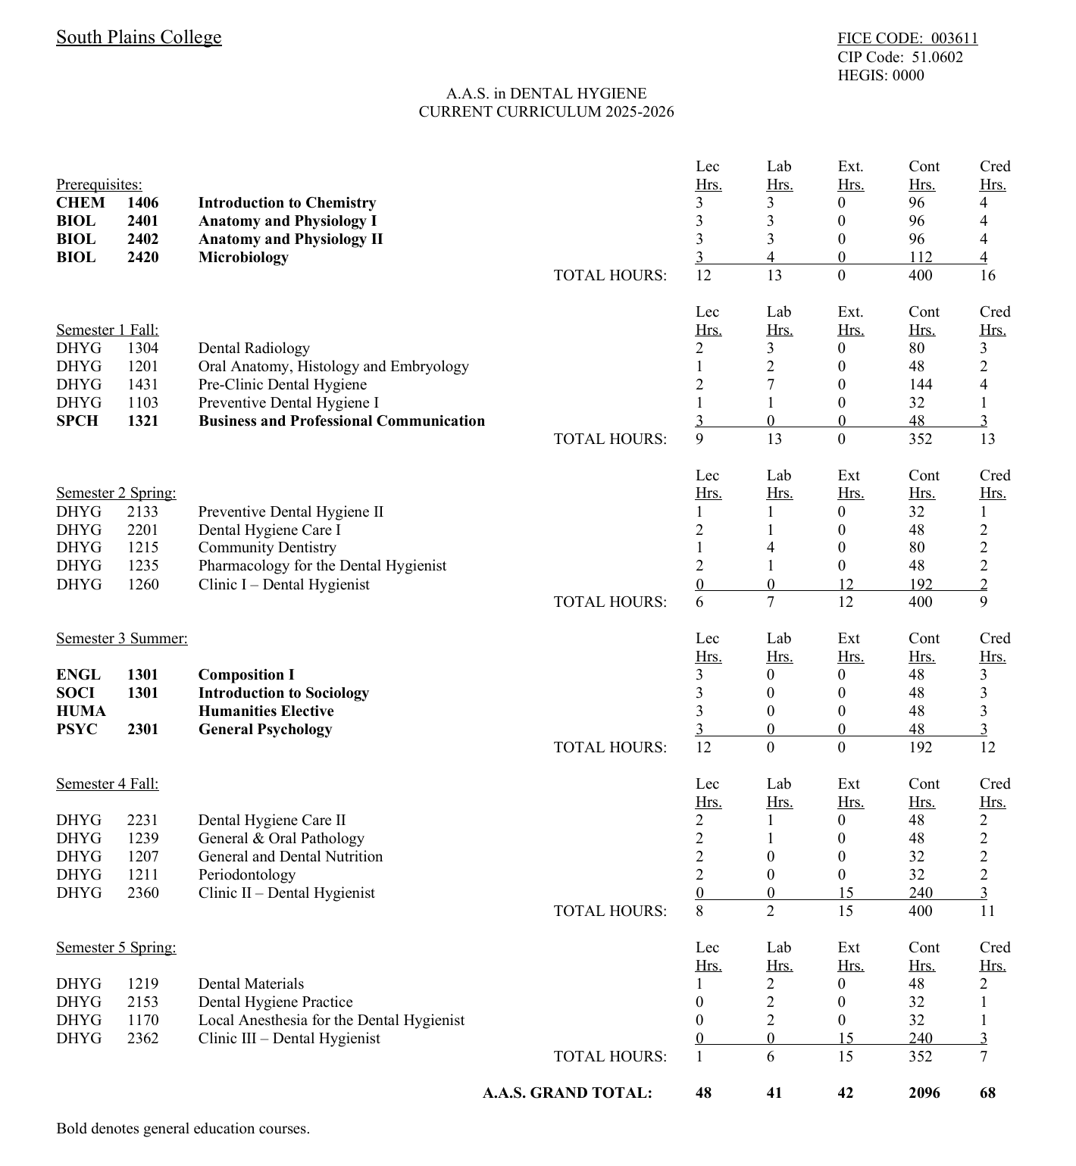
The curriculum shown is the current proposed curriculum and is subject to approval and modification as part of the accreditation process.

Estimated Program Costs
The following estimates are provided for planning purposes only and are subject to change. Tuition, fees, equipment costs, and licensing examination fees may vary.
 | First Year Expenses | Second Year Expenses
Tuition + Fees 37 hours of DHYG courses | 19 hours - https://www.southplainscollege.edu/admission-aid/paying-for-school/tuitionfees.php | 18 hours - https://www.southplainscollege.edu/admission-aid/paying-for-school/tuitionfees.php
Books | $980 | $440
Scrubs, Shoes, Lab Jackets | $350 | $200
SPC T-shirts / Sweatshirt | $100 | $100 (optional)
Instruments + handpiece | $2655 | $815
Loupes | $1500 | N/A
Student Chapter American Dental Hygienists’ Association | $85 | $85
Drug Screening | $50 | $50
Fingerprint Background Check | $50 | $50
CPR Certification | $60 | $60 (depending on renewal)
Immunizations | Varies | Varies
Physical Exam | Varies | Varies
TB Test | $40 | $40
Jurisprudence | N/A | $54
ADEX (Clinical Board Exam) | N/A | $1750
NBDHE (Written Board Exam) | N/A | $500
National Board Prep (optional) | N/A | $450
Totals | $5870 (not including tuition + fees) | $4594 (not including tuition + fees)

Frequently Asked Questions
When will the Dental Hygiene Program begin accepting applications?
South Plains College anticipates opening the application process for a Fall 2027 cohort, pending Initial Accreditation from the Commission on Dental Accreditation (CODA). The application period is expected to occur during Winter/Spring 2027. Specific application dates, deadlines, and admissions procedures will be announced through program communications and the South Plains College website once they have been finalized and all required approvals have been obtained.
Prospective applicants are encouraged to begin completing prerequisite coursework, observation hours, and HESI A2 testing requirements in advance so they are prepared when the application cycle opens.
Is the Dental Hygiene Program accredited?
No. The South Plains College Dental Hygiene Program is currently in the accreditation process and is seeking Initial Accreditation through the Commission on Dental Accreditation (CODA). Submission of an application for accreditation indicates that the institution has entered the accreditation process; however, it does not mean that the program is accredited or is guaranteed to be granted Initial Accreditation. Accreditation is granted only by the Commission on Dental Accreditation.
Can students enroll in the program before accreditation is granted?
No. South Plains College cannot enroll students into the Dental Hygiene Program until Initial Accreditation has been granted by CODA.
How many students will be accepted?
The program currently anticipates enrolling approximately 20 students in its inaugural cohort, pending accreditation approval.
What prerequisite courses are required?
Applicants should plan to complete the following prerequisite science courses:
- BIOL 2401 – Anatomy and Physiology I
- BIOL 2402 – Anatomy and Physiology II
- BIOL 2420 – Microbiology
- CHEM 1406 – Introductory Chemistry
Additional general education courses are strongly encouraged prior to application and may be considered during the admissions process.
Do prerequisite science courses expire?
Yes. Science prerequisite courses are anticipated to be valid for five (5) years from the application deadline and must be completed with a grade of "C" or higher.
What GPA is required?
Prospective applicants should anticipate a minimum cumulative GPA requirement of 2.5 on all college-level coursework completed at the time of application.
Do I need to be TSI compliant?
Yes. Applicants are expected to be TSI compliant in all areas before applying to the Dental Hygiene Program. Students who need assistance meeting TSI requirements should contact the South Plains College Advising and Testing Center.
Is the HESI A2 required?
Yes. Applicants should plan to complete the HESI A2 examination within two years of the application deadline. Required sections are expected to include Reading Comprehension, Vocabulary, Anatomy and Physiology, Critical Thinking, and Personality Profile/Learning Style.
Will the HESI A2 be available at South Plains College?
Yes. South Plains College plans to begin offering the HESI A2 examination through the Testing Center at the Levelland Campus in late June 2026. Prospective applicants are encouraged to contact the Testing Center or visit the Testing Center webpage for information regarding available testing dates, scheduling procedures, registration requirements, and testing fees.
Are observation hours required?
Yes. Prospective applicants should complete a minimum of 12 observation hours under the supervision of licensed dental hygienists. Observation hours should be completed with at least three different dental hygienists and documented using the Observation Hours Verification Form included in this packet.
Can I work while enrolled in the Dental Hygiene Program?
The Dental Hygiene Program is expected to be a rigorous, full-time educational commitment that includes classroom instruction, laboratory experiences, clinical education, and outside study time. While employment is a personal decision, students should carefully consider the demands of the program when making work commitments.
Will evening or weekend classes be offered?
No. At this time, the program is anticipated to operate primarily during daytime hours, Monday through Friday. Applicants should plan accordingly.
What if I have previously repeated a prerequisite course?
Repeated coursework may be considered during the admissions process. The higher grade is expected to be used in the evaluation process; however, point deductions may apply according to the admissions criteria in effect at the time of application.
How can I stay informed about program updates?
Prospective applicants are encouraged to regularly visit the South Plains College website and maintain contact with the Dental Hygiene Program for updates regarding accreditation status, admissions timelines, informational sessions, and future application opportunities.
Contact Information
For questions regarding the developing Dental Hygiene Program, prospective applicants are encouraged to contact:
Program Director: Lynne Contreras, MS, BSDH, CHES®
Email: lcontreras2@southplainscollege.edu
Phone: (806) 716-4635
Program updates and future application information will be posted on the South Plains College website:
www.southplainscollege.edu

