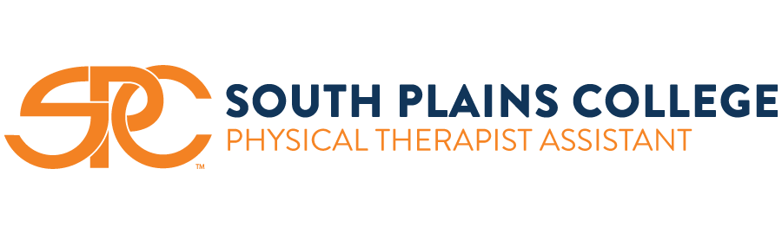

***Admission Information Sheet***

**\*Application to the SPC PTA Program involves completing the steps outlined below, most notably submitting an application through the Physical Therapist Assistant Centralized Application Service (PTACAS) (see Step #8)**

1. **[ ] Apply to South Plains College (this is a separate application).**
   1. **We recommend contacting the SPC Financial Aid Office for any questions you might have about financial aid.** [finaid@southplainscollege.edu](mailto:finaid@southplainscollege.edu)
   2. **We recommend completing an SPC Scholarship application.** [**http://www.southplainscollege.edu/admission-aid/paying-for-school/scholarships.php**](http://www.southplainscollege.edu/admission-aid/paying-for-school/scholarships.php)
2. **[ ] It is strongly recommended that you complete an advising session with PTA Program faculty. This session will answer any questions you have and ensure you have an understanding of all requirements.**
3. **[ ] You must have completed Program prerequisites (College Algebra, English Comp, Humanities, SCIT 1407 Applied A & P 1 or BIOL 2401 and 2402) and/or be currently enrolled in them (maintaining a C or higher average) before you can apply to the Program. Additional General Education courses required prior to graduation are PSYC 2314 and PHYS 1410, and can be completed before or during the Program.**
4. **[ ] Contact the SPC Testing Center ( 806.716.2530) to register for the TEAS exam (must be a minimum of 3 days in advance of testing date - please contact the Testing Center for available test dates). The cost of exam is $75.00. The test must be completed and passed prior to the application deadline. You may purchase an ATI TEAS Study Guide from the SPC Bookstore, Barnes and Noble, or Amazon. You may only retest 1 time.**
   1. **We recommend reviewing your scores with PTA Program faculty prior to submission of those scores on your PTACAS application.**
5. **[ ] Complete a minimum of 30 hours of observation of physical therapy treatment in a PT facility. Your observation hours will be recorded and reported on the PTACAS application. You are encouraged to seek out additional hours at a variety of settings to see the breadth and depth of PT practice. You may use time employed as a PT technician by having your supervisor verify hours worked.**
6. **[ ] Contact 3 people (a health care provider, a teacher, and an employer) you would like to have write letters of recommendation, and provide them with the appropriate PTACAS letter of recommendation link. Please let them know the deadline for submission 10/31. No materials will be accepted after this deadline.**
7. **[ ] Obtain OFFICIAL transcripts from each college you have attended (including from SPC and any dual credit you have earned), and submit on the PTACAS application.**
8. **[ ] Complete the PTA Program application on the Physical Therapist Assistant Centralized Application Service website (PTACAS) [**[**https://ptacas.liaisoncas.com/applicant-ux/#/login**](https://ptacas.liaisoncas.com/applicant-ux/%23/login)**].** 
   1. **Applications for the SPC PTA Program will be accepted from September 15th to October 31st.**
   2. **If a complete application is submitted, you will be asked to participate in an interview conducted on the Friday following the week of October 31st.**
   3. **A complete application and interview does not guarantee admission to the Program.**
   4. **Program courses begin each Spring.**
9. **[ ] If accepted into the Program, you will be required to:**
   1. **Attend a 2½ day orientation prior to beginning of classes**
   2. **Complete a criminal background check (CBC)**

**\*If you have a positive “hit” on your CBC, the SPC PTA Program will provide contact information for ECPTOTE so that you can verify your eligibility to license (the SPC PTA Program is not responsible for determining your eligibility for licensure.**

* 1. **Complete a drug screen**

**\*If you have a positive “hit” on your drug screen, you will not be allowed to join the Program and will not be eligible for readmission.**

* 1. **Complete a finger printing (depending on clinical placements)**

1. **[ ] If you are not accepted into the Program on your first attempt, your application can be applied to the next application year. If you are not accepted on this second attempt, you will not be able to reapply until you have strengthened your application by improvement in TEAS score, GPA, and/or observation hours.**

**If at any time you have any questions, please contact the SPC PTA Program office (806.716.2470 or 806.716.2518).**