**Lightning Talks- SPC January 10, 2020**

<https://www.youtube.com/watch?v=YTSpP0nBiAE> or under SPC “Kenny Burns Title V”

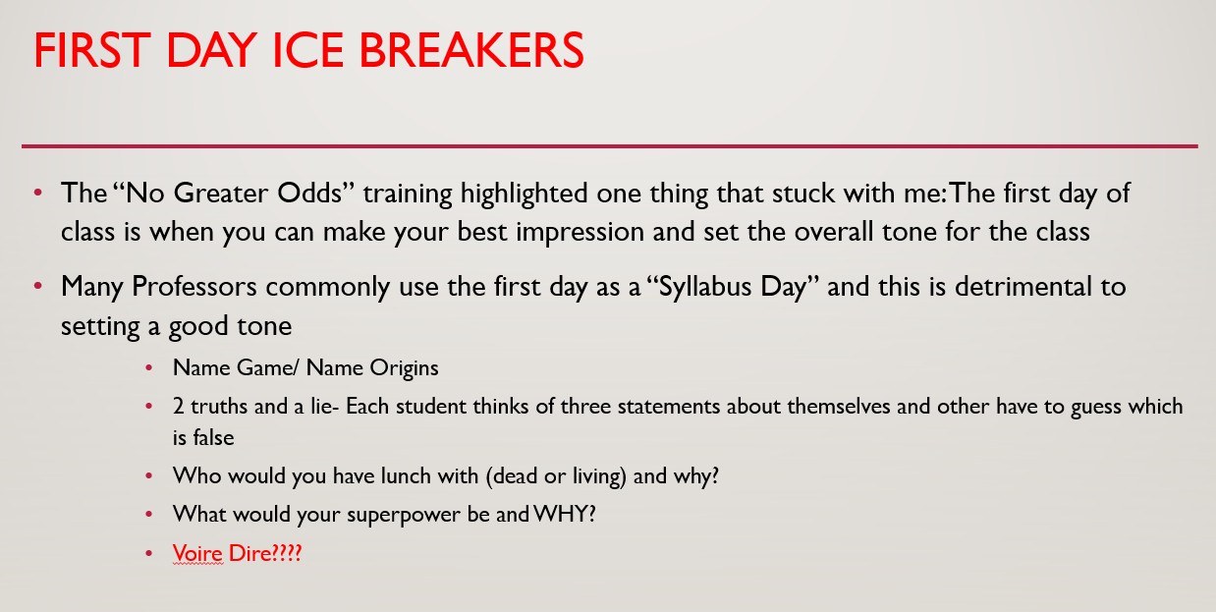

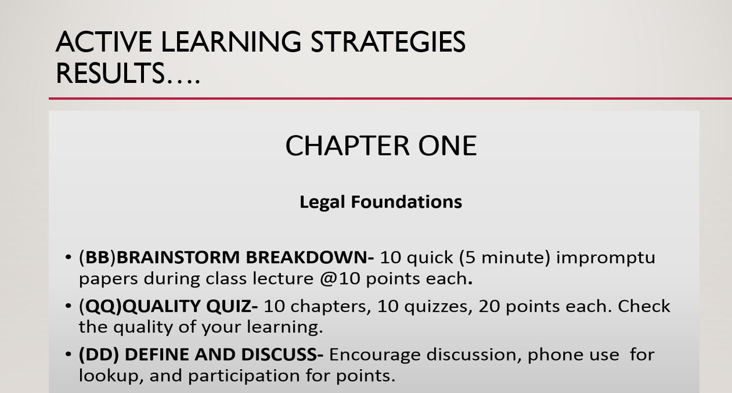

Kahoot.it

